ThinkTap User Manual
v1.0.0

Prepared by Dr. Ang Jin Sheng

Contents
Table of Figure 4
1. Introduction 5
1.1 Key Features 5
2. Basic Information 5
2.1 System Requirements 5
2.2 Accessing the System 5
3. Getting Started 5
3.1 Creating an Account 5
3.2 Login 7
3.3 Language Selection 9
4. Dashboard Overview 9
4.1 Dashboard Features 9
4.2 Creating Your First Quiz 10
5. Creating Quizzes 10
5.1 Quiz Builder Interface 10
5.2 Adding Questions 10
5.3 Editing Questions 12
5.4 Deleting Questions 12
5.5 Saving Your Quiz 12
6. Hosting Live Sessions 12
6.1 Starting a Session 12
6.2 Session Control Page 13
6.3 Key Elements 14
6.4 Starting a Session 14
6.5 During a Question 15
6.6 Showing Results 16
6.7 Moving to Next Question 17
6.8 Ending a Session 17
6.9 Background Music Control 18
7. Participating in Sessions 18
7.1 Joining a Session 18
7.2 Answering Questions 20
7.3 Viewing Results 21
7.4 Session Complete 22
8. Reports and Analytics 23
8.1 Accessing Reports 23
8.2 Features 24
8.3 Viewing Session Details 24
8.4 Participants View 25
8.5 Questions View 25
9. Session Insights 26
9.1 Accessing Insights 26
9.2 Insights Overview 26
9.3 Summary Statistics 27
9.4 Tabs 27
10. Account Management 28
10.1 Changing Language 28
10.2 Signing Out 28

Table of Figure
Figure 1: Screenshots of Homepage and Registration Button 6
Figure 2: Screenshots of Registration Form 7
Figure 3: Login Button 8
Figure 4: Login Form 8
Figure 5: Dashboard Overview 9
Figure 6: Quiz Builder Interface 10
Figure 7: Question Type 11
Figure 8: Question Form 11
Figure 9: Host Live Button 12
Figure 10: Host Lobby 13
Figure 11: Session Control Page 13
Figure 12: Game Pin and QR Code 14
Figure 13: Start Question 15
Figure 14: Question Active 16
Figure 15: Result Display 17
Figure 16: Podium Screen 18
Figure 17: Join Session Page 19
Figure 18: Participant Nickname Input Page 19
Figure 19: Waiting Screen for Participant. 20
Figure 20: Participant Screen for Q&A 20
Figure 21: Participant’s Result 21
Figure 22: Session Complete 22
Figure 24: Report Page 23
Figure 25: Report Actions 24
Figure 26: Participants View 25
Figure 27: Question View 25
Figure 28: Insights Overview 27

1. Introduction
Welcome to ThinkTap! ThinkTap is an interactive quiz platform that enables real-time engagement between educators and participants. This user manual will guide you through all the features and help you make the most of ThinkTap.

Key Features
- Real-time Interactive Quizzes: Create and host live quiz sessions
- Multiple Question Types: Support for multiple choice, true/false, multiple select
- Real-time Analytics: View participant responses and performance in real-time
- Comprehensive Reports: Access detailed analytics and insights after sessions
- Multi-language Support: Available in multiple languages
- Mobile Responsive: Works on desktop, tablet, and mobile devices

2. Basic Information

2.1 System Requirements
To use ThinkTap, you need:
- A modern web browser (Chrome, Firefox, Safari, or Edge)
- Stable internet connection

2.2 Accessing the System
Open your web browser and navigate to Thinktap ( https://thinktap.link/ ). You will be presented with the landing page.

3. Getting Started

3.1 Creating an Account
Figure 1 shows the screenshot of login page. When you access the system, you will see the login page:
1. Navigate to the ThinkTap homepage ( https://thinktap.link/ ).
2. Click the "Register" button in the top-right corner. Figure 1 shows the location of the "Register" button in the homepage which wrote "Get Started for Free".
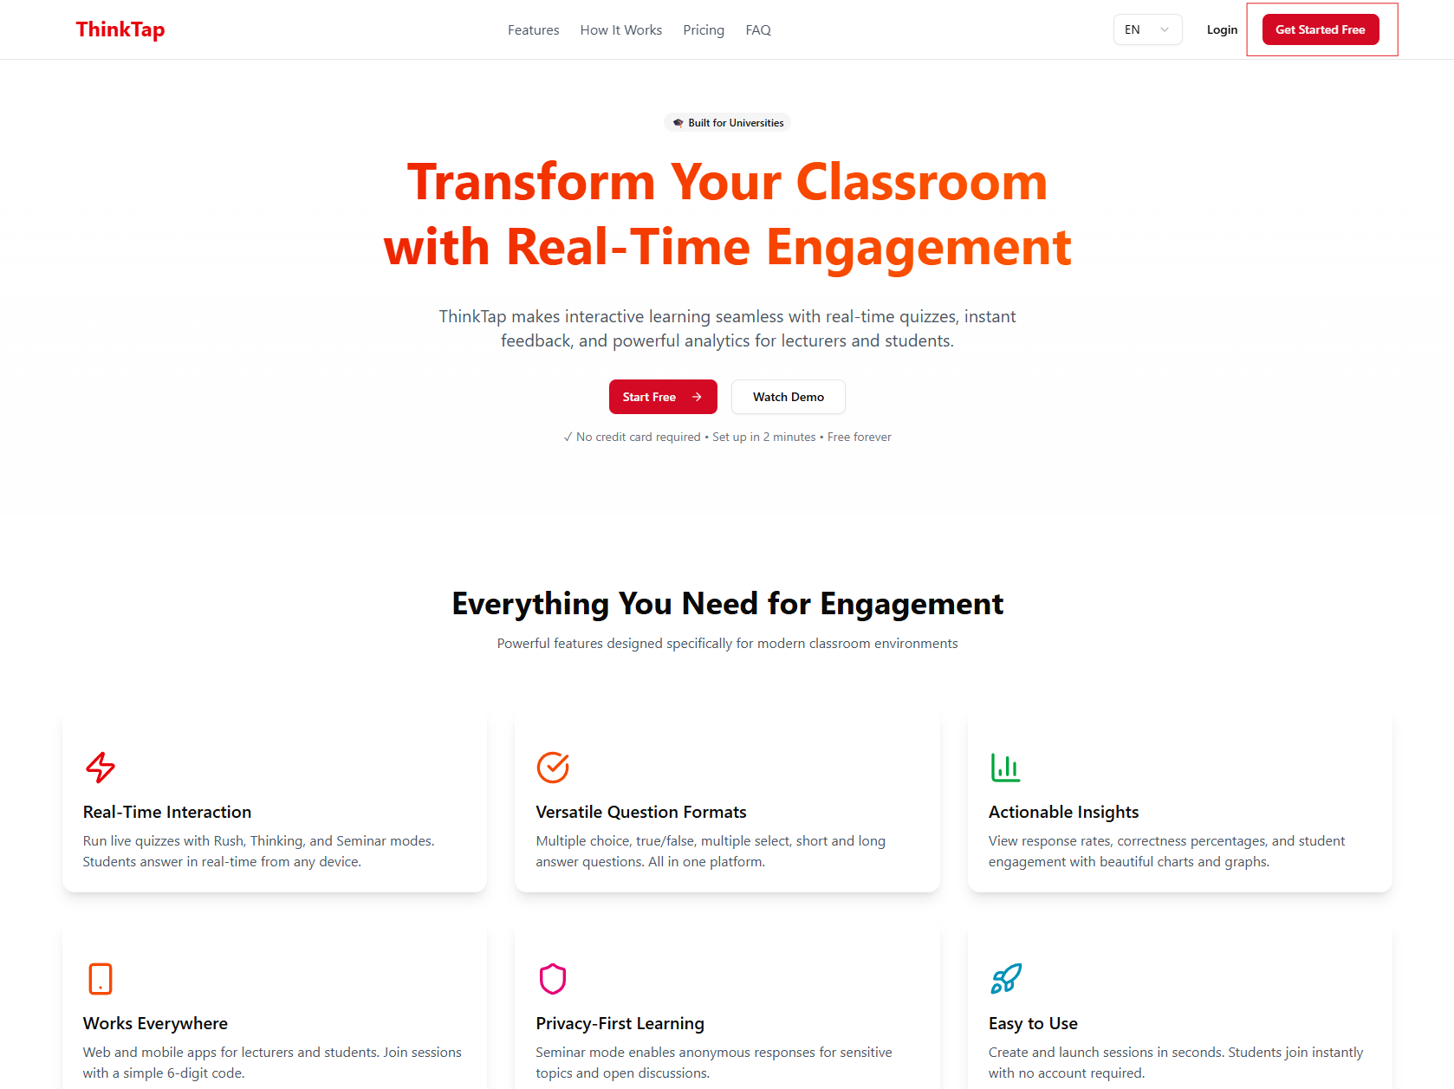
Figure 1: Screenshots of Homepage and Registration Button

3. Fill in the registration form:
- Email: Enter your email address
- Password: Create a password (minimum 8 characters)
- Confirm Password: Re-enter your password
Figure 2 shows the screenshot of registration form.
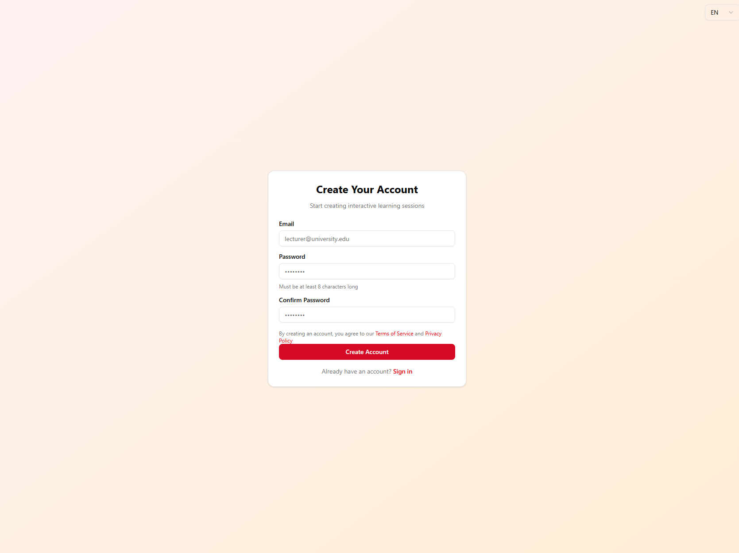
Figure 2: Screenshots of Registration Form

4. Review and accept the Terms of Service and Privacy Policy.
5. Click "Create Account"/
6. You will be automatically logged in and redirected to your dashboard/

3.2 Login
1. Navigate to the ThinkTap homepage.
2. Click the "Login" button in the top-right corner. Figure 3 shows the login button.

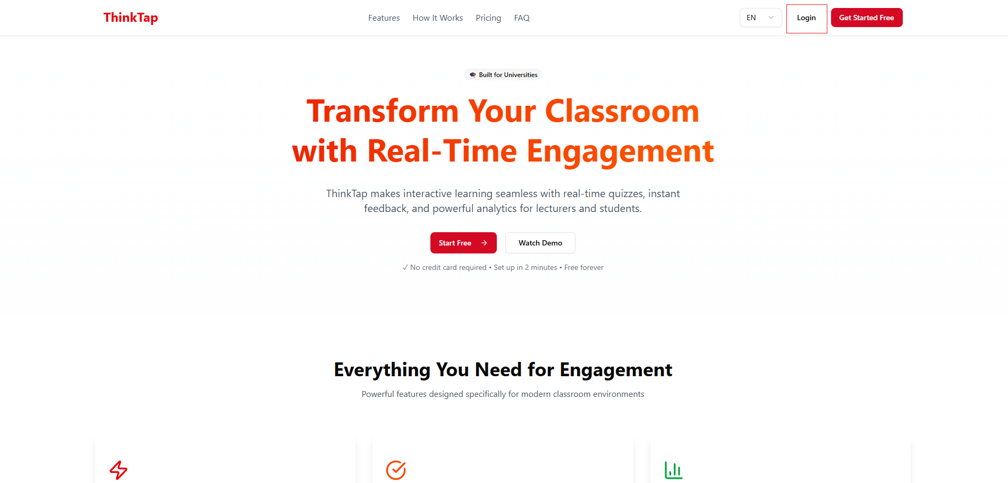
Figure 3: Login Button

3. Enter your email and password.
4. Click "Sign In". Figure 4 shows the login form.
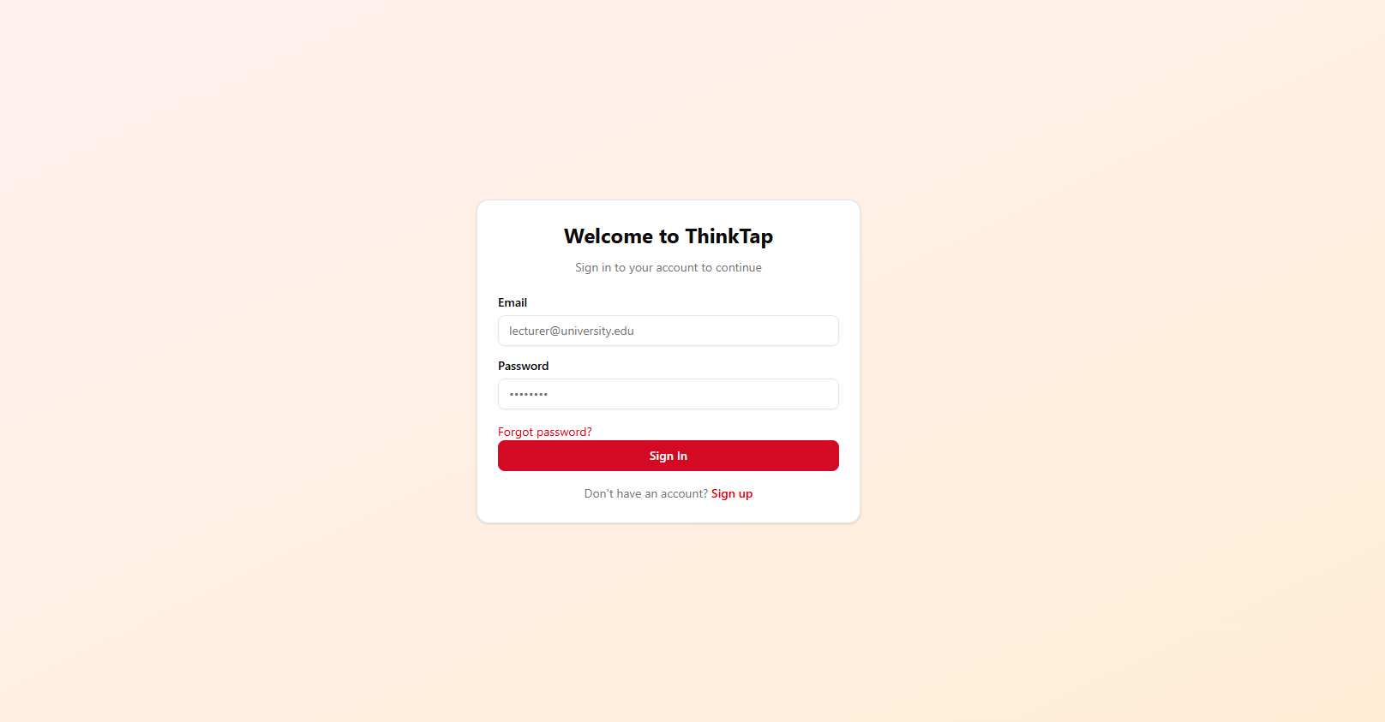
Figure 4: Login Form

5. If you've forgotten your password, click "Forgot Password?" link.

3.3 Language Selection
ThinkTap supports multiple languages. You can change the language at any time using the language switcher in the top-right corner of most pages.

4. Dashboard Overview
After logging in, you'll be taken to your Dashboard. This is your central hub for managing all your quizzes and sessions.

4.1 Dashboard Features
Figure 5 shows the screenshot of ThinkTap dashboard overview.
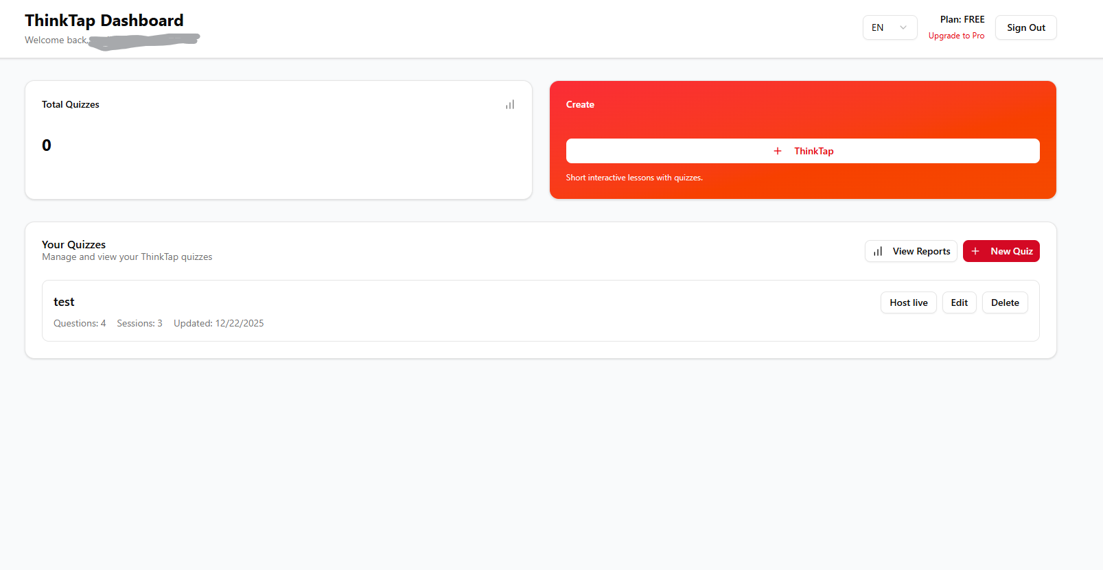
Figure 5: Dashboard Overview

The dashboard displays:
1. Header Section:
- Email and current plan
- Language switcher
- Sign out button
- Upgrade link (for Free plan users)

2. Statistics Cards:
- Total number of quizzes you've created
- Quick access to create a new quiz

3. Your Quizzes List:
- All your created quizzes
- Shows quiz title, number of questions, number of sessions, and last updated date
- Actions available for each quiz:
- Host Live: Start a live session with this quiz
- Edit: Modify the quiz content
- Delete: Remove the quiz

4.2 Creating Your First Quiz
From the dashboard, click the "Create ThinkTap" button or "New Quiz" button to start creating a quiz.

5. Creating Quizzes

5.1 Quiz Builder Interface
The quiz builder allows you to create comprehensive quizzes with multiple questions. Figure 6 shows the quiz builder interface.
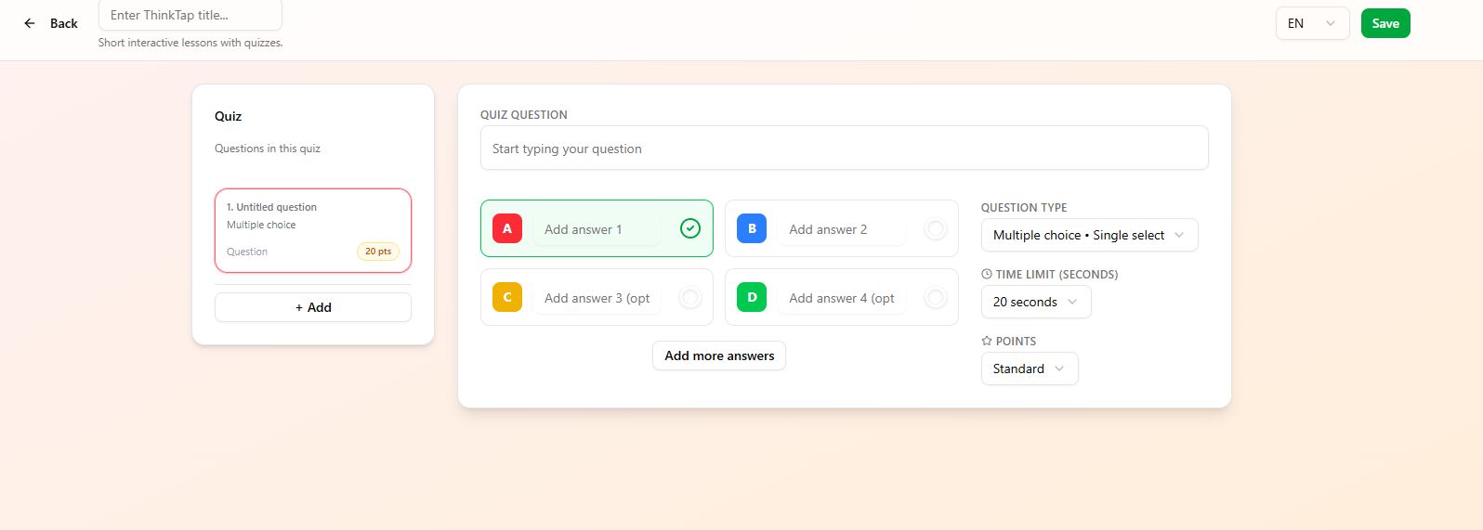
Figure 6: Quiz Builder Interface

5.2 Adding Questions
1. Click "Add Question" button.
2. Figure 7 shows the question type in ThinkTap. Select the question type:
- Multiple Choice: Single correct answer from multiple options
- True/False: Binary choice between true or false
- Multiple Select: Multiple correct answers from options

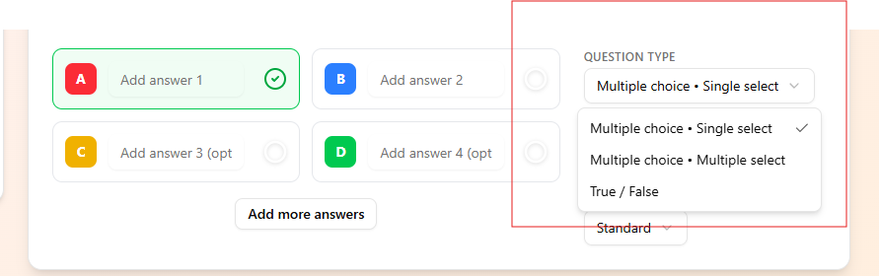
Figure 7: Question Type

3. Figure 8 shows the question form. Fill in the question details:
- Question Text: Enter your question
- Options (for multiple choice/select): Add answer options
- Correct Answer: Specify the correct answer
- Time Limit: Set how long participants have to answer (10-300 seconds)
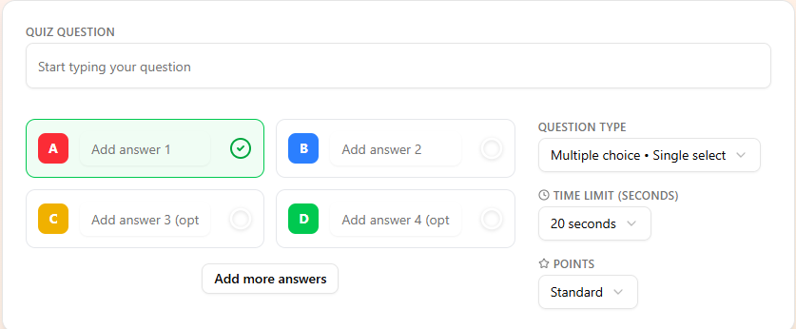
Figure 8: Question Form
4. Click "Add Question" to save.
5. Repeat to add more questions.
6. Reorder questions by dragging them up or down.

5.3 Editing Questions
1. Click on any question in the list.
2. Make your changes.
3. Click ."Save Changes"

5.4 Deleting Questions
1. Click the delete icon next to a question.
2. Confirm the deletion.

5.5 Saving Your Quiz
Your quiz is automatically saved as you work. When finished, you can:
1. Click "Back to Dashboard" to return to your quiz list.
2. Your quiz will be available for hosting live sessions.

6. Hosting Live Sessions

6.1 Starting a Session
1. From your Dashboard, find the quiz you want to host.
2. Click "Host Live" button. Figure 9 shows the host live button.
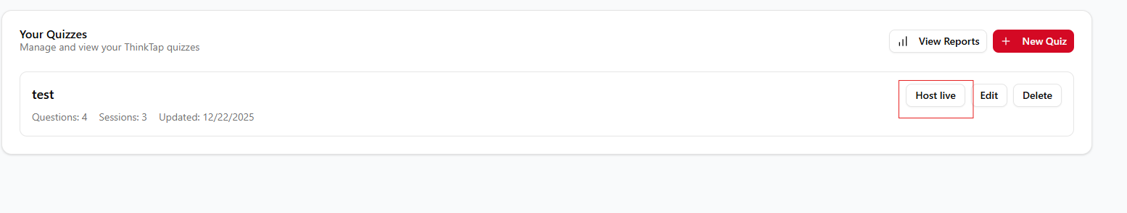
Figure 9: Host Live Button
3. You'll be taken to the host lobby. Figure 10 shows the host lobby.
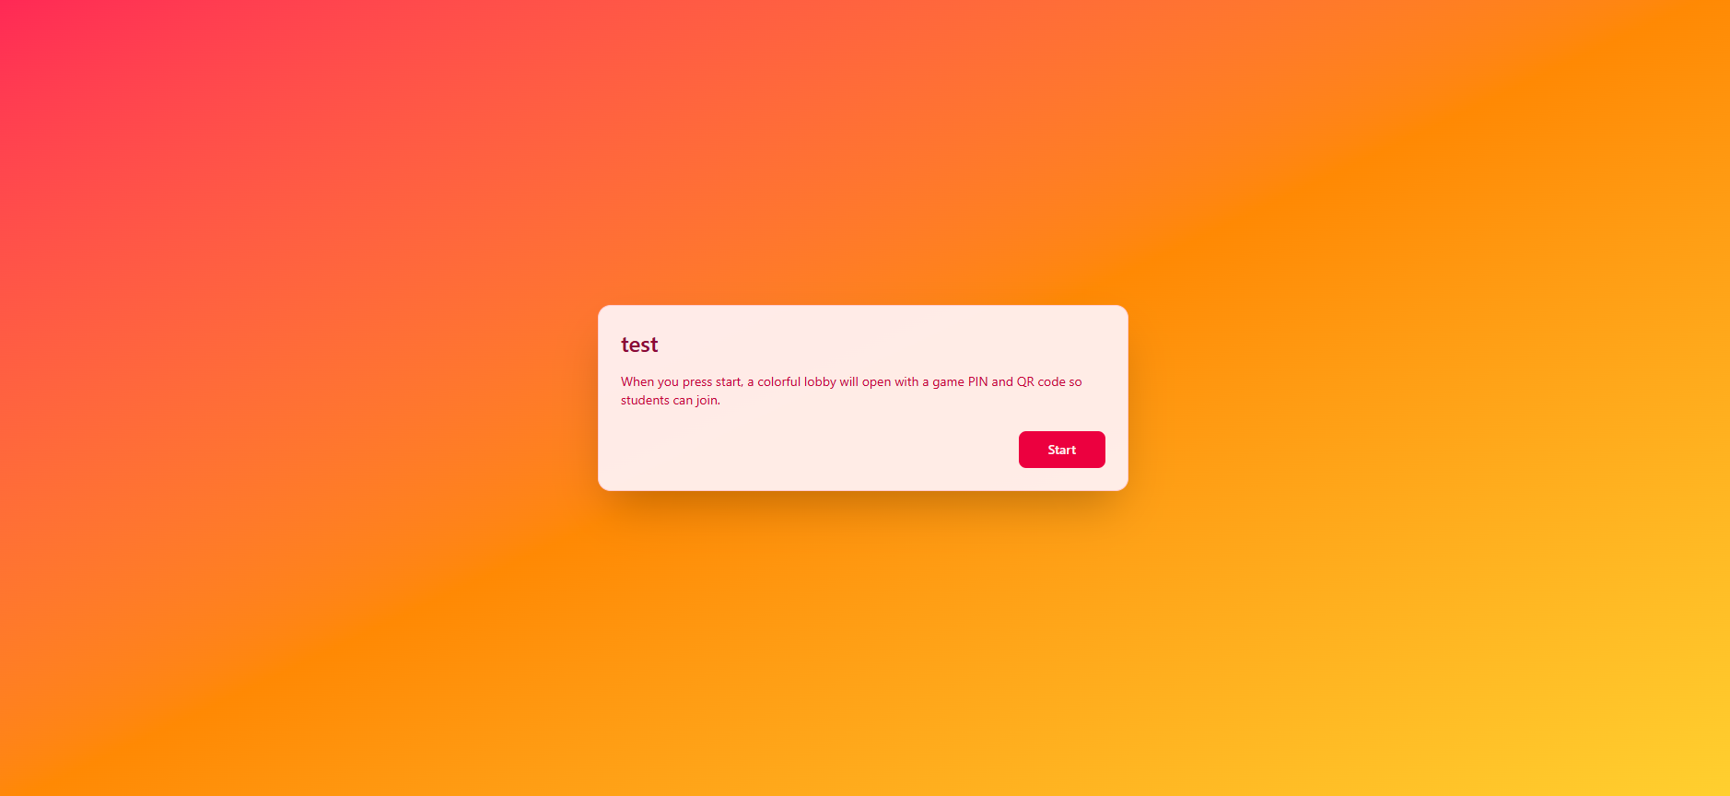
Figure 10: Host Lobby

4. Review the quiz title.
5. Click "Start" to proceed to the session control page.

6.2 Session Control Page
The session control page provides you with full control over the live session. Figure 11 shows the session control page.
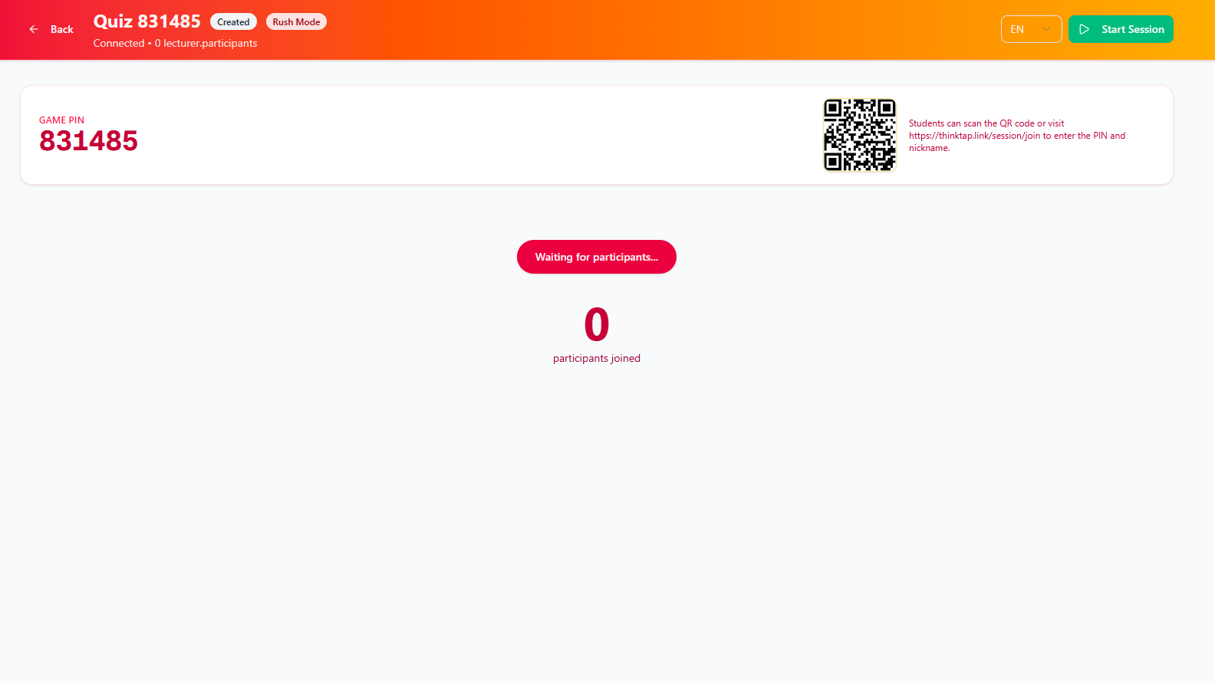
Figure 11: Session Control Page

6.3 Key Elements
1. Header:
- Quiz title and session code
- Session status badge (CREATED, ACTIVE, ENDED)
- Connection status
- Participant count
- Action buttons (Start Session, End Session, View Insights)

2. Figure 12 shows the game pin and QR code.
Game PIN & QR Code:
- 6-digit Session Code: Participants use this to join
- QR Code: Scan to join session (if available)
- Copy Code Button: Quickly copy the session code

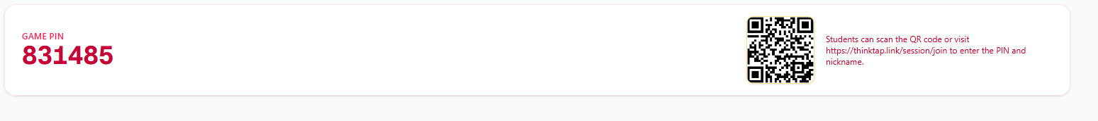
Figure 12: Game Pin and QR Code

6.4 Starting a Session
Figure 13 shows the interface after you clicked "Start Session".
1. Once participants have joined (you'll see their names displayed), click "Start Session".
2. The session status changes to ACTIVE.
3. Click "Start First Question" to begin.
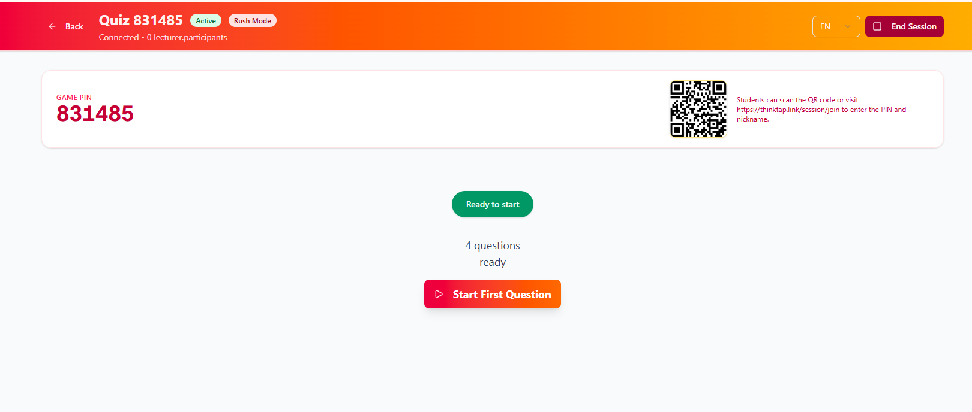
Figure 13: Start Question

6.5 During a Question
Figure 14 shows the screenshot of a question is active:
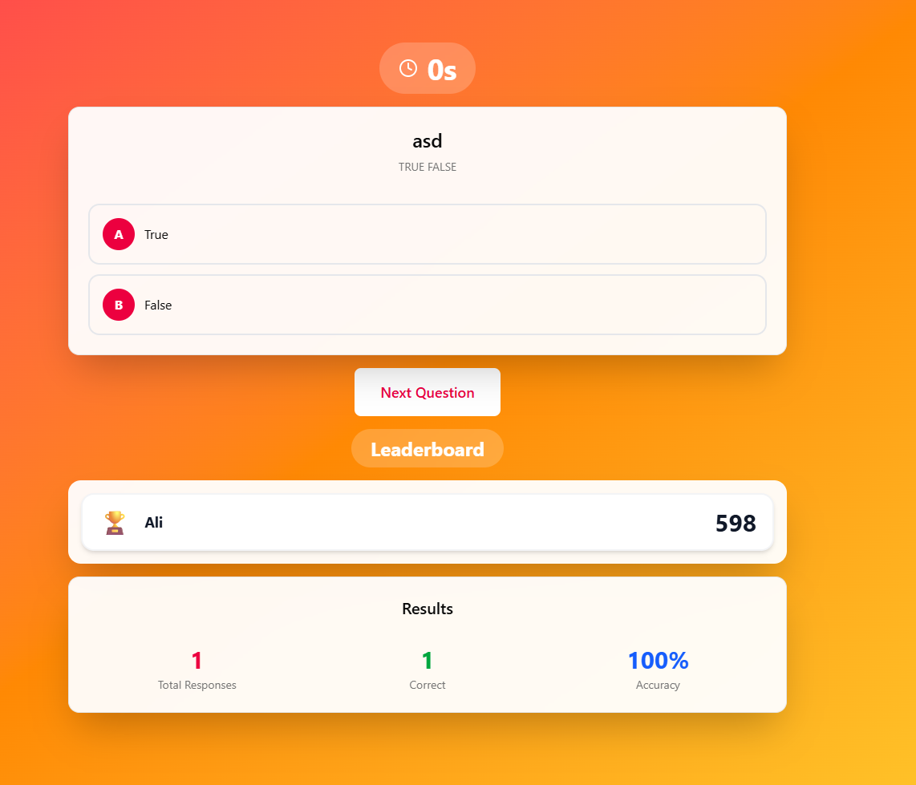
Figure 14: Question Active

Question Display in lecturer part:
- Full-screen Question Display: Shows the question and options
- Timer: Countdown showing time remaining
- Live Statistics:
- Total responses received
- Number of correct responses
- Accuracy percentage
- Leaderboard: Real-time rankings

6.6 Showing Results
Figure 15 shows the result display in participant part.
1. When the timer reaches zero or when you want to show results:
2. Click "Show Results" button.
3. Results are displayed to all participants.
4. Statistics are shown:
- Total responses
- Correct responses
- Accuracy percentage
- Response distribution
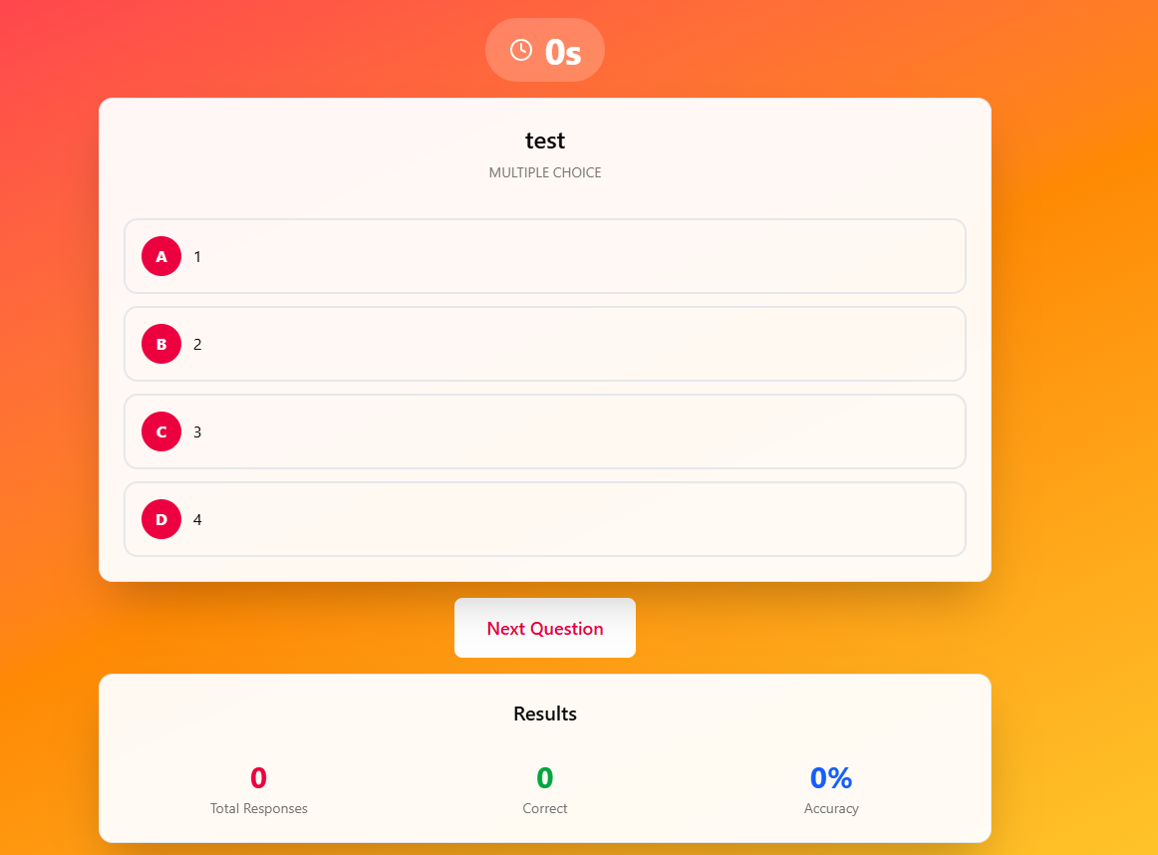
Figure 15: Result Display

6.7 Moving to Next Question
1. After showing results, click "Next Question".
2. The next question starts automatically.
3. Repeat until all questions are completed.

6.8 Ending a Session
1. After the last question, click "Finish Session".
2. Or click "End Session" at any time to stop early.
3. The podium screen will display (if enabled) showing the top 3 participants. Figure 16 shows the podium screen.
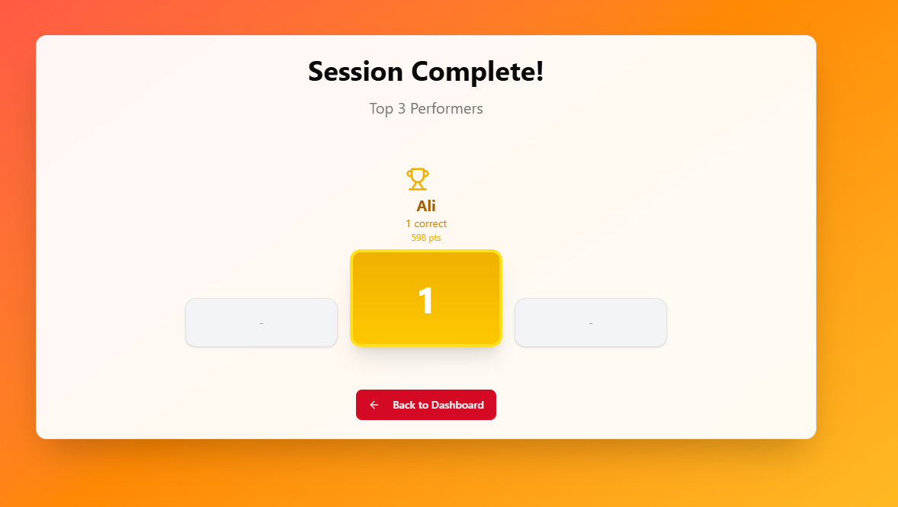
Figure 16: Podium Screen

4. Click "Back to Dashboard" to return.

6.9 Background Music Control
- Use the volume button in the bottom-right corner to mute/unmute background music.
- Music only plays on the host screen.

7. Participating in Sessions

7.1 Joining a Session
1. Navigate to the ThinkTap join page.
2. Enter the 6-digit session code provided by the host. Figure 17 shows the join session page.
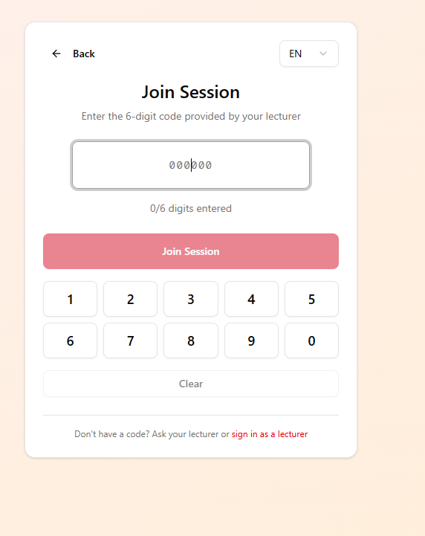
Figure 17: Join Session Page
3. Click "Join Session".
4. Enter your nickname. Figure 18 shows the page for participant to enter their nickname.
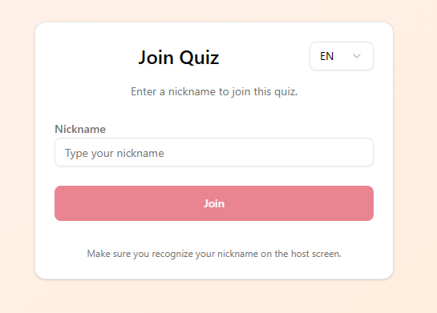
Figure 18: Participant Nickname Input Page

5. Click "Join".
6. You'll see the waiting screen until the host starts the session. Figure 19 shows the waiting screen for participant.
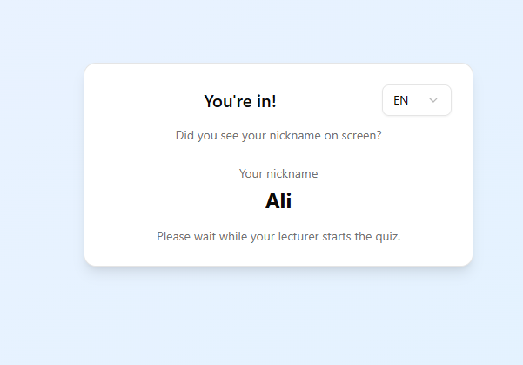
Figure 19: Waiting Screen for Participant.

7.2 Answering Questions
Figure 20 shows the screen of participant when the questions on-going.
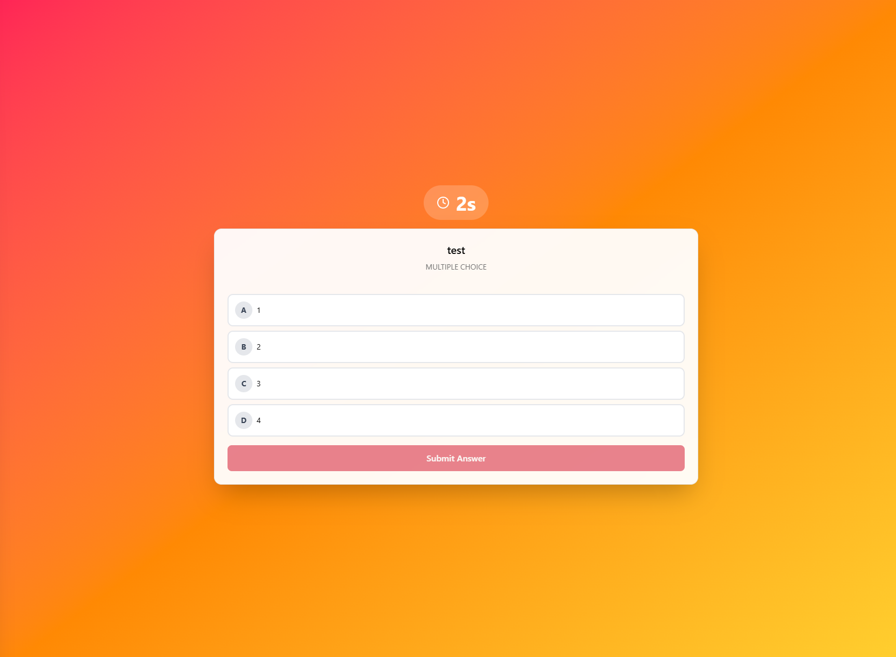
Figure 20: Participant Screen for Q&A

When a question starts:
1. Read the Question: The question and options are displayed full-screen.
2. Timer: You can see the countdown timer.
3. Select Your Answer:
- Multiple Choice/True-False: Click on your answer choice
- Multiple Select: Check all correct answers
4. Click "Submit Answer" when ready.
5. You'll see a confirmation that your response was recorded.

7.3 Viewing Results
Figure 21 shows the screen of a participant after timer ends.
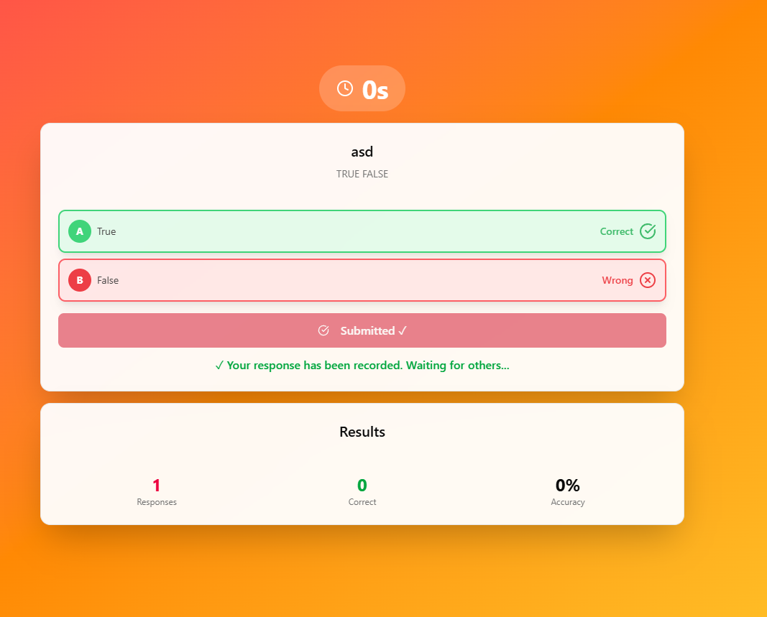
Figure 21: Participant’s Result
After the timer ends or the host shows results:
- Your Answer Highlighting:
- Green: Your answer was correct
- Red: Your answer was incorrect
- Correct answers are also highlighted in green
- Statistics: View overall response statistics
- Leaderboard: See rankings

7.4 Session Complete
Figure 22 shows the screen of participant after the session completed.
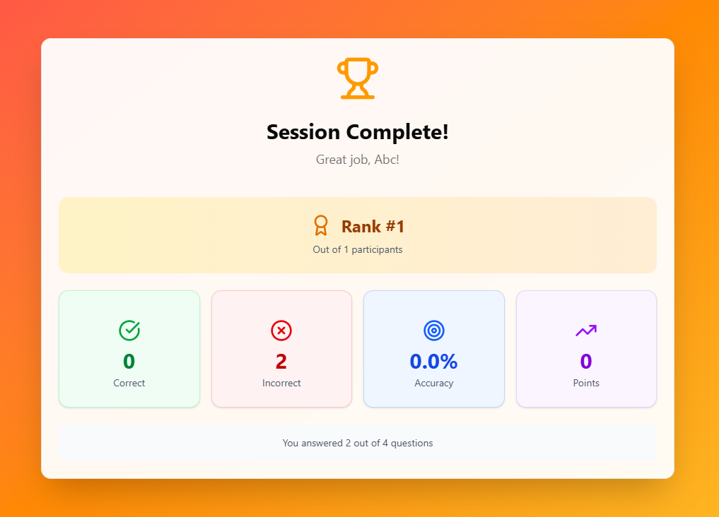
Figure 22: Session Complete
When the session ends, you'll see your personal results:
- Your Rank: Your position among all participants
- Statistics:
- Number of correct answers
- Number of incorrect answers
- Accuracy percentage
- Total points

8. Reports and Analytics

8.1 Accessing Reports
1. From your Dashboard, click "View Reports".
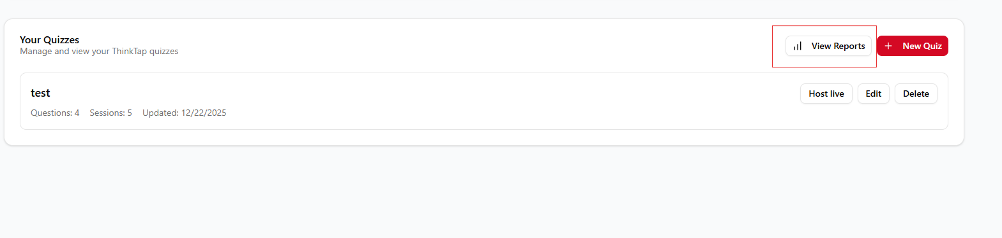

2. Or navigate to the Reports page from the menu. Figure 24 shows the report dashboard that display all the reports of every session. The Reports page shows all your completed sessions.

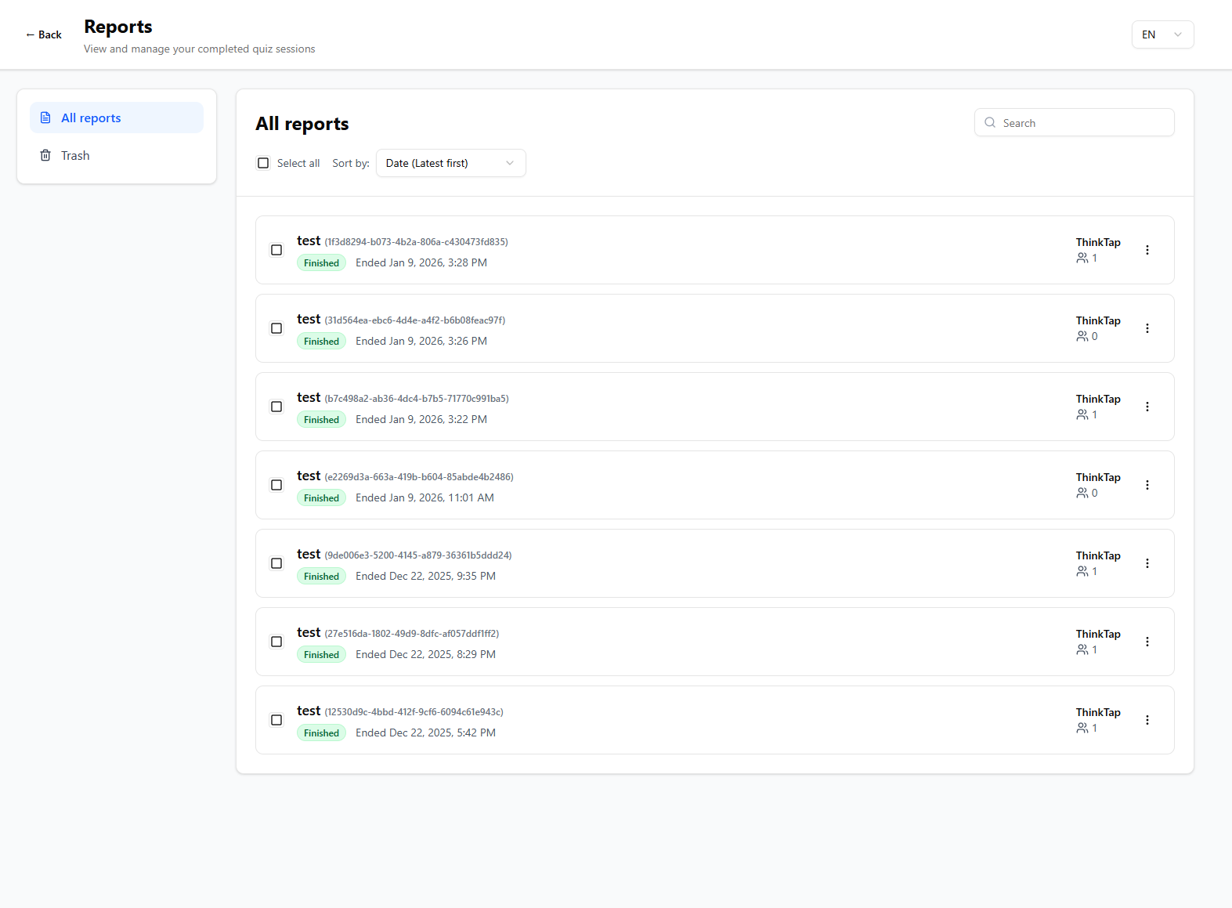
Figure 24: Report Page

8.2 Features
1. View Tabs:
- All: All completed sessions
- Trash: Deleted sessions (can be restored)
2. Search and Sort:
- Search by quiz title or session code
- Sort by date or title (ascending/descending)
3. Bulk Actions:
- Select multiple sessions
- Move to trash, restore, or permanently delete

8.3 Viewing Session Details
Figure 25 shows the actions for each report. For each session, you can:
1. View Questions: See all questions with statistics
2. View Participants: See participant performance
3. View Insights: Access detailed analytics
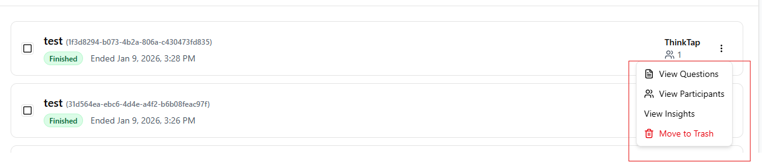
Figure 25: Report Actions

8.4 Participants View
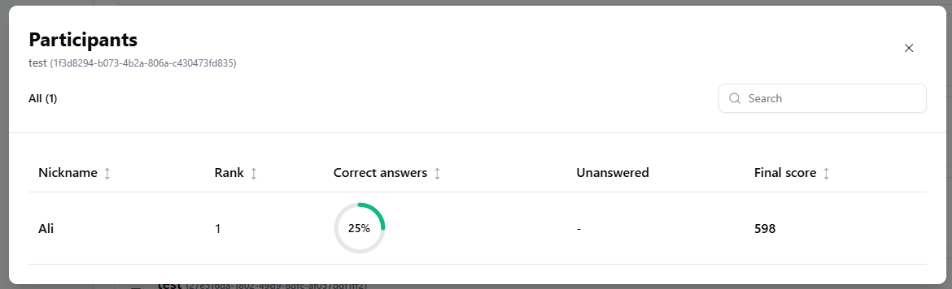
Figure 26: Participants View

Figure 26 shows the participants view of the report. It shows:
- Participant nickname
- Rank
- Correct/incorrect answers
- Unanswered questions
- Final score
- Accuracy visualization

8.5 Questions View
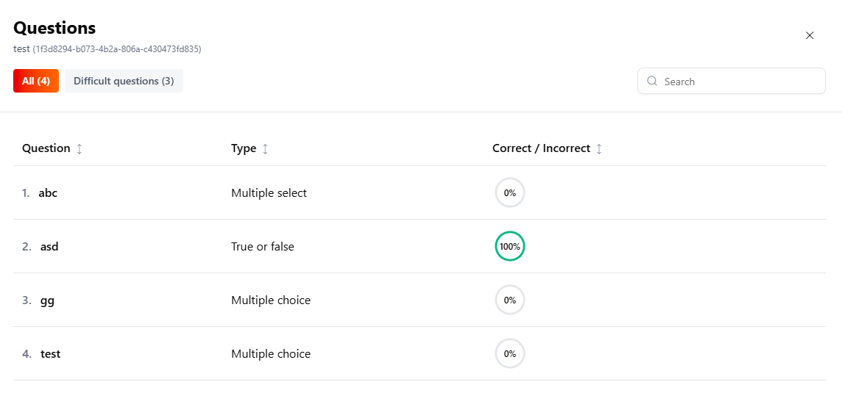
Figure 27: Question View
Figure 27 show the question view of the report. It shows:
- All questions in the session
- Question type
- Correctness rate (percentage)
- Visual accuracy indicators

Filters:
- All Questions: View all questions
- Difficult: Filter questions with <50% correctness rate

9. Session Insights
Session Insights provide comprehensive analytics for completed sessions.

9.1 Accessing Insights
1. From Reports, click "View Insights" on a session.
2. Or from the session control page after ending a session, click "View Insights".

9.2 Insights Overview
Figure 28 shows the insights for each session.
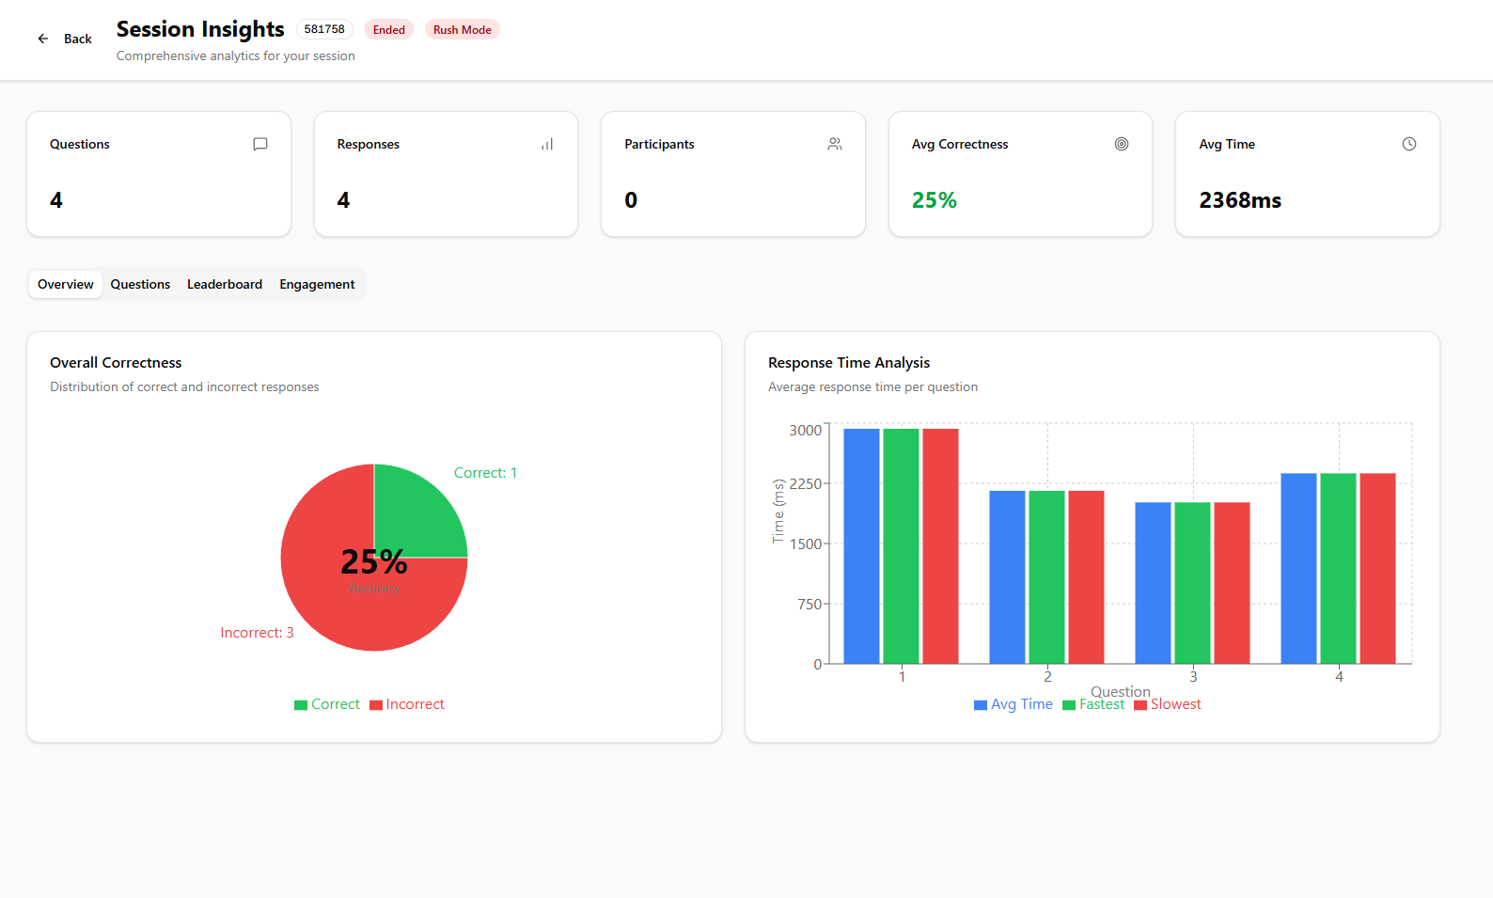
Figure 28: Insights Overview

9.3 Summary Statistics
The top of the insights page shows:
- Total Questions
- Total Responses
- Total Participants
- Average Correctness Rate
- Average Response Time

9.4 Tabs
1. Overview Tab:
- Overall correctness distribution chart
- Response time analysis chart
2. Questions Tab:
- Detailed breakdown for each question:
- Response count
- Correct/incorrect breakdown
- Average response time
- Fastest response time
- Response distribution chart
3. Leaderboard Tab:
- Final rankings
- Scores and statistics
4. Engagement Tab:
- Individual participant performance
- Participation rates
- Engagement scores

10. Account Management

10.1 Changing Language
Use the language switcher (globe icon) in the top-right corner of any page to change the interface language.

10.2 Signing Out
Click "Sign Out" in the Dashboard header to log out of your account.

